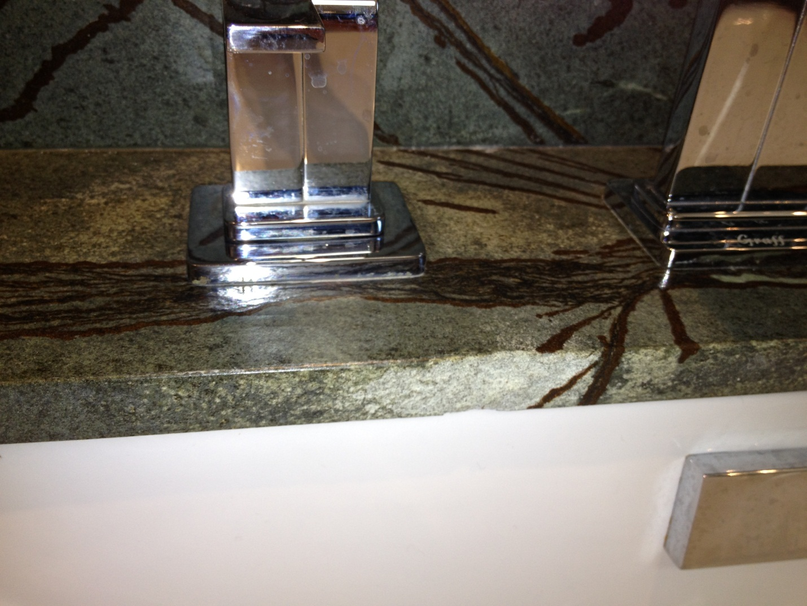

Stone is deteriorating on the edge under faucet. It is only about 2 years old.